Microsoft Word: Spanish Tools
To Type in Spanish
- Click on the language in the top right of your screen and select ‘Spanish’. To revert back to English, click back to ‘English’

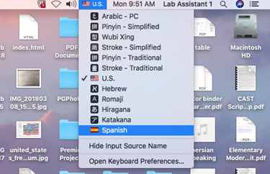 | If you do not find Spanish in the menu, go to System  Preferences/ Time and Language/ Region and Language  and add language (Win) keyboard (Mac).

- To access onscreen keyboard and view accent marks, click the apple icon on the top right of your screen and select ‘System Preferences’ click ‘Accessibility’ On the left side, scroll down and click ‘Keyboard’ On the right side, select ‘Accessibility Keyboard’ click ‘Enable Accessibility Keyboard’ box. On Windows, use Windows Logo and U.

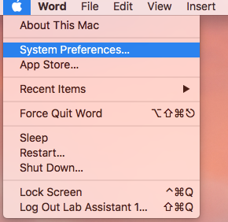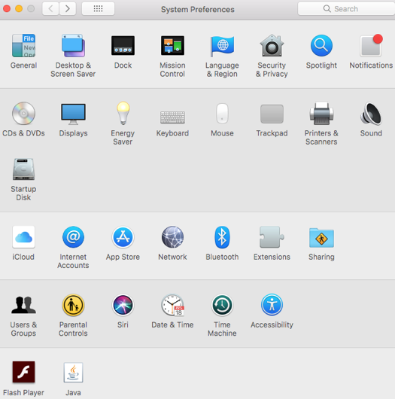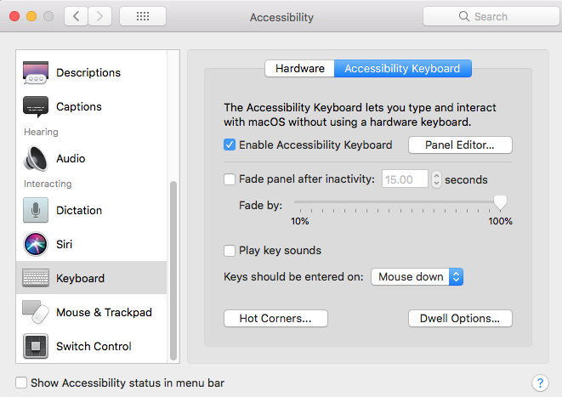

- Now you can see the onscreen keyboard and the Spanish accents and symbols. Use it to guide your spelling with the virtual keyboard or when you use the physical keyboard. To apply an accent to a letter, you must type the accent first and then the letter. Hold down the shift button to type other accents or to access the upside-down question mark.

Microsoft Word Spanish and Interpretation Tools (Thesaurus, Spelling & Grammar, Smart Lookup)

- First, be sure to set the whole document language to Spanish. Click the tab, then click , then select ‘Spanish’ (Windows: Set Proofing Language-Spanish) and hit ‘ok’. [ NOTE: Don’t have any words highlighted, this will only make the words highlighted Spanish and not the whole document. – also, you might want to check ‘default’ so the language really changes.]
- To access the Thesaurus tool in Word, go to the top of the screen and click ‘Tools’ ‘Thesaurus’. The Thesaurus tab will pop up on the right side of the screen. Type in any Spanish word in the search bar and it can search for synonyms and antonyms for that word. To access the Spelling & Grammar tool, go to the top of the screen and click ‘Tools’ ‘Spelling & Grammar’. The window will pop up and will search the entire document for any spelling & grammar errors. You can select to make changes or ignore them. NOTE: if spell check sometimes does not work, try setting the language again in Microsoft Word or setting Spanish as default language.
- To access the Smart Lookup tool, first highlight the word or phrase, then go to the top of the screen and click ‘Tools’ ‘Smart Lookup’. The Smart Lookup tab will pop up on the right side of the screen. This will show web searches pertaining to those specific words you highlighted.
- STYLES – Don’t use boldface or italic, choose styles such as “heading, normal, etc.” by clicking the ‘Styles Pane’ on the right of your screen. When your document is saved, it will be ADA compliant or accessible to those with vision impairment.

